Software System Design
Document Specification

Emperor Sushi Website

Version: 1.0

By Megan McNamee, Brian Calabrese and Justin Winn

Date: 11/24/2020

Table of Contents

Introduction 3
Application Architecture 5
System Functions 6
User Interface 7
Components 10
Database 11
Required Hardware and Software 12
Appendix A 14

Table of Figures

Figure 1. Application Architecture 5
Figure 2. User Interface 5
Figure 3. 6
Figure 4. 12

1. Introduction
Emperor Sushi is a fan made sushi restaurant based in Staten Island, NY. This web application displays the food available to order while also displaying photos of featured classic sushi items. The user will be able to make an account (for special offers), add items to cart, remove from cart, and browse through given tabs.
2. Application Architecture
The application architecture is composed four major parts which are: Website, User, Food and Database. First the user enters the website (by logging in). After the user is done browsing food items (which the information is transferred from the database) and adding food items to cart, they go to checkout. Then the user can complete their order.
3. Required System Functions
Required system functions for this application is registering all the food items the user adds to their cart to order. The user will also have the option to remove any items and/or add on more quantity of an item. We also have function keys for login, logout and sign up. We are still configuring our functions to properly execute.

4. User Interface
One way the user can interact with the application system is they have access to the database. There the user will see a list of food items to add to their cart. The user can also have an account and log in. The user will be given to enter a username and password then confirming their information.

Interface/Wireframe concept:

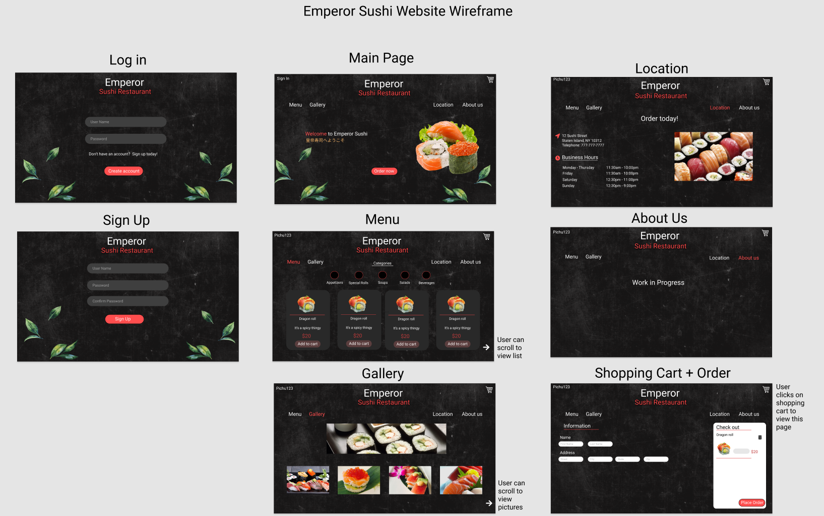
5. System Components
List of system components or modules, their functions and how they interact with each other.
Name | Function Description | Input Data | Output Data | Dependencies
Food item | Description of food | Quantity amount added to cart | Display shopped food items | Quantity of food items
6. Database
We have multiple tables. These are our tables so far:
Cart (ID, User, Ordered)
CartItem(ID, Item, Quantity, Cart)
MenuItem9ID, ItemName, ItemPrice, ItemDescription, InStock, Category)
Orders(ID, Cart)
Users(ID, Username, Password, LastSeen, SessionKey)

7. Required Software and Hardware
Any device running PHP, HTML and C#
Appendix – If any. (N/A)

